Data Flow Diagram & User Stories

Date | 23 September 2026
Team ID | SWTID-2026-9722
Project Name | AI Weatherwise

Data flow diagram:
Context / Overview: The system takes user registration/login data, location queries, and external weather requests. It authenticates users via JWT tokens, stores user-preferred locations in MongoDB via Mongoose models, fetches live meteorological data from the OpenWeather API, and generates clothing/activity recommendations using the Google Gemini AI service (with rule-based fallbacks).

Flow:
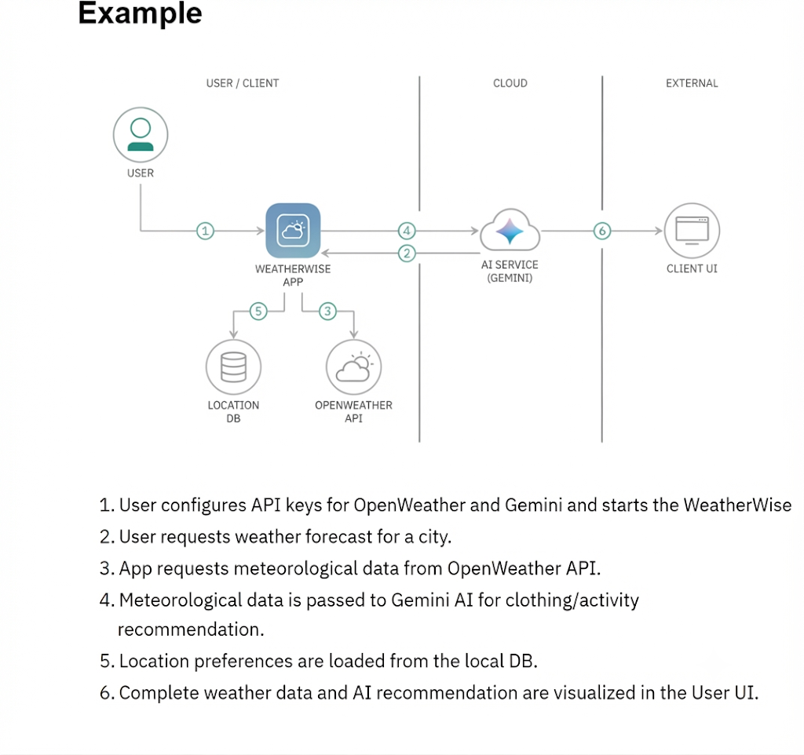

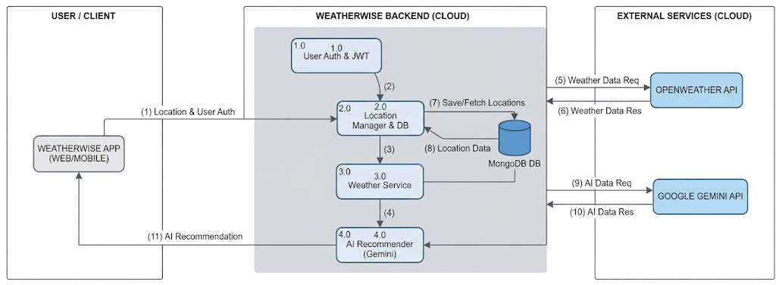

User Stories:
Use the below template to list all the user stories for the product.
User Type | Functional Requirement (Epic) | User Story Number | User Story / Task | Acceptance criteria | Priority | Release
Customer (Web user) | Registration | USN-1 | As a user, I can register for the application by entering my name, email and password. | I can access my account/dashboard upon successful creation and receive a JWT token | High | Sprint-1
 | Login | USN-2 | As a user, I can log into the application by entering my registered email and password. | I receive a valid JWT token and get authenticated to manage locations. | High | Sprint-1
 | Weather Management | USN-3 | As a user, I can search for current weather conditions by entering a city name. | I can view current temperature, humidity, wind speed, and weather conditions for the specified city. | High | Sprint-1
 | AI Recommendation | USN-4 | As a user, I can request an AI-generated weather recommendation based on current meteorological data. | I receive a tailored 1-sentence clothing/comfort suggestion factoring in temperature and humidity. | Medium | Sprint-2
 | Location Management | USN-5 | As a user, I can save my favorite cities and retrieve my saved locations list. | I can successfully add and fetch locations associated with my authenticated account profile. | High | Sprint-2

